Variansen er givet ved:

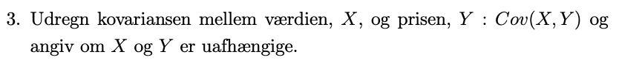



Den forventede pris, når kvaliteten er 1100.

